**Information office intelligent agent**

Final Year Project

Session 2021-2025

A project submitted in partial fulfillment of the degree of

BS in Data Science



Department of Software Engineering

Faculty of Computer Science & Information Technology

The Superior University, Lahore

Fall 2021

|  |  |  |  |  |  |
| --- | --- | --- | --- | --- | --- |
| Type (Nature of project) | | | [ ✓ ] **D**evelopment [ ] **R**esearch [ ] **R**&**D** | | |
| Area of specialization | | | Data Science ,AI,NLP,ML | | |
| FYP ID | | | FYP-BSDSM-F24-003 | | |
| **Project Group Members** | | | | | |
| Sr.# | Reg. # | Student Name | | Email ID | *Signature |
| (i) | Bdsm-f21-011 | Faisal Rehman | | Bdsm-f21-011@superior.edu.pk |  |
| (ii) | Bsaim-f23-011 | Fahad Jamshad | | Su92-bsaim-f23-011@superior.edu.pk |  |
| (iii) |  |  | |  |  |

*The candidates confirm that the work submitted is their own and appropriate credit has been given where reference has been made to work of others

# Plagiarism Free Certificate

This is to certify that, I ________ S/D of Muhammad Siddique, group leader of FYP under registration no ______________________________at Software Engineering Department, The Superior College, Lahore. I declare that my FYP report is checked by my supervisor.

Date:  Name of Group Leader: _________________ Signature: _____________

Name of Supervisor: Dr. ABC Co-Supervisor: Mr. XYZ

Designation: Lecturer Designation: Associate Professor

Signature: ________________ Signature: _________________

HoD: Dr. Arfan Jaffar

Signature: _______________

**Project Report**

**Information office intelligent agent**

**Change Record**

|  |  |  |  |  |
| --- | --- | --- | --- | --- |
| **Author(s)** | **Version** | **Date** | **Notes** | **Supervisor’s Signature** |
|  | 1.0 |  | <Original Draft> |  |
|  |  |  | <Changes Based on Feedback from Supervisor> |  |
|  |  |  | <Changes Based on Feedback From Faculty> |  |
|  |  |  | <Added Project Plan> |  |
|  |  |  | <Changes Based on Feedback from Supervisor> |  |
|  |  |  |  |  |
|  |  |  |  |  |
|  |  |  |  |  |
|  |  |  |  |  |
|  |  |  |  |  |

**APPROVAL**

|  |  |
| --- | --- |
| **Project Supervisor** | |
| Comments: ___________________________________________________________________ | | |
| _____________________________________________________________________________ | | |
| Name:______________________________ |  | |
| Date:_______________________________ | Signature:__________________________ | |

|  |  |
| --- | --- |
| **Project Manager** | |
| Comments: ___________________________________________________________________ | |
| _____________________________________________________________________________ | |
|  |  |
| Date:_______________________________ | Signature:__________________________ |

|  |  |
| --- | --- |
| **Head of the Department** | |
| Comments: ___________________________________________________________________ | |
| _____________________________________________________________________________ | |
|  |  |
| Date:_______________________________ | Signature:__________________________ |

# Dedication

This project is lovingly dedicated to my dearest father and mother, whose unwavering support, encouragement, and sacrifices have been the cornerstone of my achievements.

To my father, whose wisdom, guidance, and belief in my abilities have always inspired me to aim higher.

To my mother, whose endless love, prayers, and nurturing spirit have been my greatest strength throughout this journey.

This work stands as a testament to the values you have instilled in me, and I am forever grateful for your presence in my life.

With all my heart, this milestone is dedicated to you.

# Acknowledgements

We would like to express our deepest gratitude to our esteemed supervisor,for his unwavering support, guidance, and encouragement throughout the journey of our Final Year Project. His vast knowledge and invaluable insights have been instrumental in shaping our understanding and refining our work.

dedication to teaching and mentorship has not only helped us navigate the complexities of our project but also instilled in us a profound sense of commitment and professionalism. His patience, constructive feedback, and willingness to share his expertise have been truly inspiring and have greatly enriched our learning experience.

We are sincerely thankful for his continuous motivation and for providing us with the tools and confidence to overcome challenges and achieve our goals. This project would not have been possible without his guidance and mentorship.

Thank you, **Dr. Hafiz Shahz,** for being a pillar of support and a source of inspiration throughout this journey.

# Executive Summary

This project aims to design and implement an intelligent agent chatbot for a university information office to automate responses to student, faculty, and staff inquiries. The chatbot leverages Natural Language Processing (NLP) and Machine Learning (ML) to understand and respond to user queries efficiently, reducing administrative workload and improving service accessibility.

Traditional university information offices handle a high volume of repetitive questions, leading to delays and inefficiencies. This project addresses these challenges by developing a voice and text-enabled chatbot capable of providing 24/7 support, handling FAQs, and assisting with administrative tasks such as course registration, policy clarification, and campus navigation.

The chatbot is built using state-of-the-art NLP models for intent recognition and response generation, ensuring context-aware and personalized interactions. Key features include:

Natural language understanding for accurate query interpretation

Machine learning-based adaptation to improve responses over time

Multi-lingual support for diverse users

Integration with university databases for real-time information retrieval

Testing and evaluation demonstrate that the chatbot significantly reduces response time, improves user satisfaction, and decreases staff workload. Future enhancements could include voice recognition, sentiment analysis, and predictive assistance based on user behavior.

This project contributes to AI-driven automation in higher education, showcasing how intelligent agents can enhance administrative efficiency while delivering a seamless user experience.

# Table of Contents

JuristApp i

Final Year Project i

Session 2015-2019 (Chamge as per your session) i

BS in Software Engineering i

*The candidates confirm that the work submitted is their own and appropriate credit has been given where reference has been made to work of others ii

Plagiarism Free Certificate ii

Dedication v

Acknowledgements vi

Executive Summary vii

Table of Contents viii

List of Figures ix

List of Tables xi

Chapter 1 1

Introduction 1

1.1 Background 2

1.2 Motivations and Challenges 3

1.3 Goals and Objectives 4

1.4 Literature Review/Existing Solutions 5

1.5 Gap Analysis 11

1.6 Proposed Solution 12

1.7 Project Plan 13

1.7.1 Work Breakdown Structure 16

1.7.2 Roles & Responsibility Matrix 18

1.7.3 Gantt Chart 21

1.8 Empathy Map 21

Chapter 2 22

Data Collection 22

2 : Data Collection 23

2.1 Introduction 23

2.1.1 Sources of Data 23

2.1.2 Access the Data 23

2.2 Data preparation 23

2.3 Data Storage 24

2.4 Data Validation 24

2.5 Data privacy and security 24

Chapter 3 25

Data Exploration 25

3 Data Exploration 26

3.1 Description of Dataset 26

3.2 Descriptive statistics 26

3.3 Visualizations 27

3.4 Data Correlation 30

Chapter 4 31

Data Cleaning 31

4 Data Cleaning 32

4.1 Description of the data cleaning process 32

4.2 Identification of data issues: 32

4.3 Handling of missing values: 32

4.4 Handling of inconsistencies: 32

4.5 Data type conversion: 33

4.6 Data normalization: 33

4.7 Conclusion: 33

Chapter 5 34

Purposed Methodology 34

# List of Figures

1.7 Gantt Chart 21

1.8 Empathy Map 21

3.1 Reported cases sorted by Year 27

3.2 Total Crime By Year Represented in Bar chart 28

3.3 Total Crimes Over the Years 28

3.4 Representation of Burglary, Robbery and Motor Vehicle Theft 29

3.5 Representation of Attempted Murder, Murder in 2020 29

5.1 Architecture Diagram 37

# List of Tables

1.1 Roles & Responsibility Matrix 19

# Chapter 1

# Introduction

Introduction:

In the current dynamic academic landscape, university information offices are experiencing an ever-growing influx of inquiries from students, faculty members, and administrative staff. These queries span a wide range—from straightforward administrative matters, such as admissions processes, course enrolment, and examination timetables, to more intricate issues concerning institutional policies, campus resources, and academic support services. Traditionally, addressing such a broad spectrum of questions has demanded substantial human resources, often resulting in delayed responses, inconsistencies in the information provided, and rising operational expenses. Consequently, the demand for a more efficient, scalable, and user-centric solution has become increasingly urgent.

Recent advancements in Artificial Intelligence (AI) and Natural Language Processing (NLP) have introduced intelligent agents—particularly chatbots—as highly effective tools for automating and improving information delivery. Unlike earlier rule-based systems, which depended heavily on rigid, pre-programmed scripts, contemporary AI-powered chatbots utilise machine learning (ML) techniques to interpret user intent, adapt through interactions, and deliver responses that are both accurate and contextually appropriate. These qualities make them particularly well-suited for university environments, where enquiries often follow recognisable patterns but still require tailored and precise information.

## Background

The rapid digital transformation across different industries has led people to expect quick, accurate, and round-the-clock access to information. However, many higher education institutions have been slower to keep up with this trend. University information offices, which are the main point of contact for student enquiries, still depend heavily on traditional methods. These include face-to-face service counters, email responses that often take time, basic FAQ pages that require manual searching, and telephone helplines with limited hours. As student numbers grow and academic administration becomes more complex, these old methods are struggling to meet demand. According to a 2022 study by the European University Association, 68% of universities reported major delays in responding to student queries, causing frustration among students and inefficiencies in administration. The rise of artificial intelligence (AI), especially intelligent agents like chatbots, offers a powerful solution to these problems.

Intelligent agents have already proven successful in areas such as customer service (for banks and online stores), healthcare (for checking symptoms and managing appointments), and government information services. In the education sector, early chatbot systems were basic and could only answer simple, pre-set questions. Thanks to advances in natural language processing (NLP) and machine learning (ML), today’s chatbots can understand more complex questions, remember the context of a conversation, learn from user interactions, and connect with backend systems. Universities increasingly need these AI-driven solutions because of several reasons: more students without enough new staff, students’ expectations for instant answers, the need to support multiple languages for international students, the growing complexity of academic programs, and the goal to use staff time more effectively by automating repetitive tasks.

This project is built on the latest developments in NLP, including technologies like BERT and GPT, which help the system recognise what users mean and pick out important information from their messages. It also uses dialogue management systems to make conversations flow naturally. Machine learning methods such as supervised learning (to train the system how to respond), reinforcement learning (to help it improve over time), and sentiment analysis (to better understand and serve users) further enhance the chatbot’s performance. System integration is another important part of the project, connecting the chatbot securely to student information systems, using strong authentication methods, and hosting the solution on the cloud for better scalability and reliability.

However, there are specific challenges in building chatbots for universities. These include understanding academic language, protecting student privacy, working with older university systems that are not easily compatible, making sure the information provided is accurate, and encouraging both students and staff to use the system.

This project tackles these challenges by creating an intelligent agent that combines advanced technology with practical design choices. It uses powerful NLP techniques to manage complicated enquiries while ensuring security and compatibility. By automating common questions, the chatbot will reduce the workload on university staff, speed up response times, and improve the overall experience for students, faculty, and administrators. The background of this project shows why AI-powered chatbots are a much-needed solution in today’s university environment. They help institutions meet the rising expectations of their users while managing limited resources more efficiently. Through continuous learning and improvement, the system aims to set a new benchmark for smart, accessible, and reliable information services in higher education.

## Motivations and Challenges

**Motivation**

The motivation behind developing JuristApp Pakistan is rooted in the desire to increase the availability and credibility of legal aid service throughout the country of Pakistan. By the use of modern technology, JuristApp alleviates all these challenges providing the users with an accurate, personalized, and culturally relevant approach to recommend the right legal actions as most citizens barely understand, or could navigate complex legal codes or afford the services of professional consultation thereby exposing them to false information and deceit by some localized legal guidance by individuals.

**Challenges**

Nevertheless, the project encounters considerable challenges, such as obtaining thorough and current legal datasets, building user trust in a such sensitive domain, and implementing advanced technologies like NLP and machine learning tailored for a localized environment. Moreover, addressing ethical issues, maintaining the protection of data regulations, and acquiring the necessary resources to create and maintain such a platform are vital challenges. In spite of these challenges, JuristApp seeks to transform legal support by developing a tool that is effective, easy to use, and customized for Pakistan’s unique legal landscape.

## Goals and Objectives

The main goal of JuristApp Pakistan is to radically change the traditional methods of legal consultations through improving its availability, effectiveness in meeting the needs of individuals from Pakistan in terms of legal aid. This is achieved with the creation of a system which delivers highly specific, specific legal information by jurisdiction and makes it easy to use. Main goals consist of:

**Delivering Accessible Legal Insights:** To eliminate the existing gap in legal knowledge and to enable others with clear, concise, relevant legal advise within Pakistan’s legal framework.

**Improving Effectiveness in Legal Support:** To reduce and minimize the complexity of the process to seek for legal services, thereby reducing reliance on expensive and lengthy consultation.

**Utilizing Cutting-Edge Technology:** To ensure that the replies produced are contextually perfect, the following technologies are used; advanced NLP, machine learning, and RAG.

**Adapting to Evolving Legal Standards:** To guarantee and ensure that the platforms remains up to date with its position as informative platform of legal codes and regulations, maintaining its relevance and reliability with the updated base of codes and regulations.

**Promoting Legal Knowledge:** The use of this medium granted it the opportunity to ensure awareness for the legal rights as well as knowledge in legal procedures so it could help in uplifting and liberating the society for the improvement of the future.

## Literature Review/Existing Solutions

In this Research Paper Analysis is done on Old and Modernizing Punishment in Pakistan,which examines the disciplinary regimes written in Pakistan Penal code (PPC), drafted in 1860 during the British colonial era. However its foundation remains largely retributive, which focuses on harsh punishments which includes fines, imprisonment and even the death penalty even after many its been amended over the years. The study recommends shift to the new paradigm that emphasizes crime justice’s objectives in reintegrating offenders back into the society as well as in delivering justice.

Unlike many modern penal systems like those in Singapore, China, and UK, Pakistan's legal framework still heavily emphasizes discouragement and prefer an prioritizing punishment over reintegration. Singapore incorporates rehabilitative measures like community service and supervised reform programs, while China emphasizes public surveillance and corrective labor as alternatives to incarceration. Meanwhile, the high rates of imprisonment and capital punishment in Pakistan disproportionately affect the most marginalized individuals and have left prisons filled to capacity with insufficient infrastructure to reintegrate those released.

This study highlights the need to align Pakistan’s penal code with contemporary global standards, especially in the face of emerging challenges such as cybercrime and human rights violations, which the current system lacks the effectiveness of the solution. JuristApp plays a transformational role by making these inadequacies visible and making people aware of the need for improvement. By providing up-to-date legal definitions and comparative insights, JuristApp not only educates users on existing limitations but also recommends judicial reforms to create a modern legal system if it balances Pakistan’s needs by drawing inspiration from international best practice.[2][1]

This Research article explores the historical evolution and professional implication of PPC as a law pertaining to freedom of press and highlights the complexities of regulation and expression. Founded under British colonial rule, the PPC was intended as a device to preserve order and suppress dissent. Amendments after independence, technically sound as they were intended to contextualize the law for Pakistan, created further curbs on press freedom. Also contained there are sections 124-A (sedition) and 499 (defamation), which have been used through regimes to repress dissent, go after journalists, and control information flow. Although these laws exist in an effort to maintain harmony in society, they’ve often come at a cost one that creates tensions between the authority of the state and the right to free speaking.

In contrast, PPC in the United States, where the First Amendment provides strong protections for the press, and in the European Union, where freedom of expression is balanced against the right to freedom of expression that his reliance on privacy underscores state sovereignty, public policy and ethical values ​​Recommends aT Rethinking of the PPC policy for the media in order to conform with modernity democratic values ​​will align well, ensuring that regulation doesn’t so destroy the integrity of the media. JuristApp could be important in simplifying legal interpretation for journalists, news organizations and policymakers, helping them to balance the legal process with freedom of expression. By providing clear, local insights, JuristApp promotes a better understanding of the law and supports a balanced approach that respects public needs and individual rights .[3]

.This research paper explore the historical development and commercial significance of the PPC as a regulation of freedom of the press, highlighting the complexities of legislation and advocacy Established during British colonial rule, it was developed the PPC in order to remain organized and overcome opposition.. Amendments after independence, technically sound as they were intended to contextualize the law for Pakistan, created further curbs on press freedom. Also contained there are sections 124-A (sedition) and 499 (defamation), which have been used through regimes to repress dissent, go after journalists, and control information flow. Although these laws exist in an effort to maintain harmony in society, they’ve often come at a cost — one that creates tensions between the authority of the state and the right to free speaking.

This paper investigates the nature of the socio-economic determinants of crime levels in Pakistan for the period 1972–2011, extending the understanding of a remaining social problem. The study emphasizes potential crime motivating factors including unemployment, poverty, and inequality in income distribution and proved the long-run positive relationship between all crimes and them. The study identifies the primary factors contributing to crime, including unemployment, poverty, and income disparity, which have a sustained positive link with various criminal actions. Therefore, Unemployment also minimizes on the cost to be incurred in committing crimes and poverty and economic stress put an individual into pressure to engage in an act without having to think of the consequences had. On the other hand, the outcomes show that education and, specifically, higher education become the most significant discouragement, as it raises the cost pf crime by providing better paid jobs and enhancing people’s perceiving of the norms.

This work also reveals trends in crime over the geographic and demographic aspects. Mega cities, where the standard population density and or income gap is high has more criminal activities than in rural settings where there are few cases due to many reasons such as high level of social compactness and anonymity. Also, the research focuses on the relationship between economic development and crime rate controlling that for countries with higher GDP per capita the crime rate decreases in the very short term, but for the long-term view, the picture is rather mildly different due to the problem of inequality in economic development.

This evidence strengthens the call to put in place polices that deal with the causes of crime such as employment, poverty, and education. So, by targeting the concern aims of socio-economic equity, Pakistan can avoid the roots which call crimes and help criminals thus, maintain the sustainable society.[4]

The study done in this research paper investigates the complex relationship between urbanization and crime in Pakistan, filling a critical gap in the literature by empirically examining how rapid urban growth contributes to rising criminal activities. Utilizing time series data from 1963 to 2008 and employing Johansen cointegration analysis, the research establishes a robust positive correlation between urbanization and crime rates. It points out that careless and poorly handle urbanization deepens socio-economic problems such as unemployment inflation, and Wealth gaps, which contribute to an environment conducive to crime. In densely populated areas with higher demographic concentrations, where people are less familiar with each other, crimes like theft are more likely to occur, robbery, and organized criminal activities more than in rural areas where there is strong community pull combatting criminal activities. Education in particular emerges as a crime mitigating factor in the prison study. Higher levels of education are linked to reduced crime rates, as they improve economic opportunities and promote social cohesion. However, this relationship is not absolute, as economic disparities often overshadow the benefits of education in high-stress urban environments. The authors argue that irregular urban migration exacerbates this disparity, creating pockets of poverty that act as hotbeds of crime.

The study highlights the urgent need for effective urban planning to meet the challenges posed by rapid urbanization. Strategies such as urban core areas with adequate infrastructure, prevention of migration and promotion of rural employment, control of inflation and reduction of urban crime have been suggested Policy makers are encouraged to take approach balancing economic growth with broader crime prevention measures to achieve safe and equitable urban areas where You can.[5]

The present articles gives us the present study look at the different provinces in Pakistan and examine socio-economic and structural causes that have seemingly facilitated the consistently violent trend between the years 2009 to 2013. This was followed by other aspects that include poverty, unemployment, rapid urbanization, inflation and weak governance considered as influential leading factors of criminal activities. Gunning down, bombings, kidnaps, robberies, vehicle jacking and others are some of the crimes which are recognized as common and are abounding particularly in big cities such as Karachi, Lahore and Pesahawar. Such cities experience high crime rates relating to population concern, high unemployment levels, and inadequate structures of policing.

A significant conclusion of the study is the reluctance of citizens to report crimes to the police due to low public confidence in the police and people's frustration with the excessively prolonged legal processes. Insufficient investigation process of the police and lack-of-appropriate mechanisms for prosecution increases public anger and frustrations, and make them feel powerless. Because of this lack of responsibility, offenders continue with the horrible acts creating a culture of violence. Additionally, the research showed that the severe tactics employed by law enforcement typically do not tackle the fundamental socio-economic factors that push individuals toward criminal behavior. In comparison to rural areas, urban centers are particularly vulnerable due to their anonymity and the socio-economic disparities inherent to rapid urban growth. The research highlights the economic consequences of unchecked violence, such as declining foreign investments, disrupted trade, and a loss of public trust in state institutions.

The authors support a comprehensive strategy to tackle violence, stressing the importance of improved governance, fair socio-economic policies, and effective law enforcement systems. Their recommendations involve upgrading police training, reforming judicial processes, and investing in education and employment opportunities to tackle the underlying causes of crime. By adopting these measures, Pakistan can aspire to mitigate the culture of violence that endangers its socio-economic stability and the welfare of its citizens.[6]

This research focuses on Punjab, Pakistan to explore the social and economic determinants of property crimes and the data was extracted from 35 districts of Punjab for the year of 2018. By the use of OLS regression analysis, the study identifies key factors like poverty, population density, literacy level, migrant population, number of known offender identified by police, and police capacity influence property crimes in a given region or state. The findings reveal that while poverty, population density, and migrant influxes have a significant positive impact on property crime rates, literacy levels and police strength demonstrate a negative correlation, acting as deterrents. This is good evidence that highlights some factors that organisational socio-economic factors and law enforcement effectiveness when dealing with property crimes.

The property crimes such as robbery, dacoity, motor vehicle theft and burglary are most frequently reported in urban populated areas. The article states that these areas afford opportunity to practice criminal activities given the propensity for anonymity and according to the prevailing inequality, economic. Migrant populations, often concentrated in urban centers, are also linked to higher crime rates, attributed to their socio-economic vulnerabilities and lack of community integration. Conversely, districts with stronger law enforcement presence and higher literacy rates experience reduced property crime rates, emphasizing the role of education and police efficiency as crucial deterrents.

The research highlights the limitations of existing law enforcement practices in effectively addressing property crimes. Even with the increase of more police workforce, the lack an absence of modern tools, inadequate training, and week inter agency coordination limit their ability and capacity to respond quickly and effectively. Such inefficiencies not only fuels crime but also becomes the reason of weakening of trust between police and the public.

To mitigate property crimes, the authors propose a multi-pronged approach involving socio-economic reforms and institutional enhancements. Suggestions involve specific poverty reduction programs, educational efforts to enhance literacy levels, and infrastructure improvements in rural regions to diminish urban migration. Additionally, equipping law enforcement with cutting-edge technology, streamlining investigative procedures, and fostering collaboration between the police and the community are suggested to boost overall efficiency.

By addressing the fundamental socio-economic issues and enacting effective policy reforms, Punjab can strive to build safer communities and markedly decrease property crimes. This holistic strategy not only bolsters crime prevention initiatives but also enhances public confidence in the government's dedication and ability to protect its citizens. By tackling the root causes of criminal behavior and reinforcing institutional responses, the region can foster a more resilient society where individuals feel secure and are motivated to contribute to the common good.[7]

## Gap Analysis

Some of the issues affecting legal aid system in Pakistan include; poor working, limited accessibility, and poor localization. Even current platforms such as ChatGPT and Gemini do not respond to the requirements of the complex legislation of the Islamic state of Pakistan, the PPC, CrPC, and CPC.. These platforms do not address the localized context, leading to incomplete or irrelevant guidance for users navigating Pakistan’s judicial system.

The socio-economic conditions highlighted in existing research, such as poverty, unemployment, and urbanization, exacerbate legal challenges for marginalized communities. Inefficient law enforcement and limited public awareness further widen the gap in delivering timely and accurate legal assistance. Studies reveal that property crimes, socio-economic disparities, and lack of access to education significantly contribute to legal complexities, yet existing solutions fail to address these underlying causes effectively.

Comparatively, other countries with modern legal systems, such as Singapore and the UK, integrate rehabilitative justice models and advanced legal technologies to ensure equitable legal assistance. Pakistan, however, remains heavily reliant on punitive measures and outdated processes, making it difficult for citizens to access or understand their legal rights.

JuristApp addresses these gaps by offering a localized, user-friendly platform specifically tailored to Pakistan’s legal system. Through technologies like NLP and RAG, it provides concise, actionable, and jurisdiction-specific legal guidance. This not only bridges the accessibility gap but also empowers users to navigate legal challenges effectively while promoting trust in the judicial system.

## Proposed Solution

**Proposed Solution:**

To address the challenges posed by generic legal chatbots that often fail to provide precise, jurisdiction-specific responses, we propose the development of JuristApp Pakistan. This specialized legal assistant platform will deliver accurate, context-aware legal guidance tailored to Pakistan's legal framework.

**Key Features of JuristApp Pakistan:**

**Localized Legal Advice:** The platform is solely dedicated to provide information about laws in Pakistan, thus providing the user precise information according to the Pakistan Penal Code (PPC), Civil Procedure Code (CPC) and Criminal Procedure Code (CrPC).

**Keyword-Based Extraction:** JuristApp will employ Natural Language Processing to determine the specific legal vocabulary used by the user in the input message to create a reliable match with all corresponding legal provisions.

**Concise and Clear Responses:** By providing clear, direct answers, the platform will improve user accessibility and understanding of complex legal information.

**Continuous Learning and Adaptation:** JuristApp will ensure that it will include machine learning algorithms necessary to upgrade the performance of the app by embracing the new legal standards.

**User-Friendly Interface:** To fit this demand, it will be very sleek, appealing to individual users and legal practitioners who need a direct and straightforward means of finding legal advice.

**Efficient Workflow:** The app will streamline legal research, reducing the need for extensive manual work by advocates, allowing them to focus on more complex legal matters.

**Integration of Advanced Technologies:**

Langchain will be integrated to enhance data retrieval capabilities, making the app more responsive and efficient in handling legal queries.Retrieval-Augmented Generation (RAG) will be used to combine retrieved legal data with generative model outputs, ensuring the accuracy and relevance of the provided information.

## Project Plan

**Introduction:**

**Objective** To develop JuristApp Pakistan, a legal assistant platform using NLP and LLMs for providing precise, localized legal information based on Pakistan’s law codes.

Scope: The app will address the limitations of generic chatbots by offering jurisdiction-specific legal advice tailored to Pakistani laws, ensuring reliability and relevance for users.

**2. Project Goals**

* Provide Accurate Legal Assistance: Legal questions should be answered with specific information for Pakistan PPC, CPC and CrPC.
* Enhance Accessibility: Create situations when individuals, small business, and even legal professionals can find legal services to solve their problems without having to rely on expensive consultations.
* Leverage Advanced Technologies: Implement Natural Language Processing (NLP), Retrieval-Augmented Generation (RAG), and machine learning for user-specific responses.
* Support Continuous Learning: Integrate machine learning mechanisms to adapt to evolving legal standards and enhance accuracy over time.
* Develop User-Friendly Interfaces: Provide an intuitive mobile application compatible with Android and iOS platforms.

**3. Project Deliverables**

* Functional Chatbot System:
* Trained on PPC, CPC, CrPC legal texts.
* Keyword-based extraction for precise query resolution.

Mobile Application:

* Cross-platform compatibility using frameworks like React Native or Flutter.
* Login/registration module for user authentication.

Backend System:

* Developed with Python/Django, using cloud databases like AWS RDS or Firebase.
* Machine Learning Integration:
* Self-learning mechanisms for improving response accuracy over time.

Documentation:

* Technical documentation for the system.
* User manuals for legal professionals and general users.

**4. Project Timeline**

Phase 1: Planning & Research (Month 1)

* Define project requirements.
* Perform competitive analysis of existing systems (e.g., ChatGPT, Gemini).
* Finalize the dataset of PPC, CPC, and CrPC for training.

Phase 2: Design & Development (Months 2-4)

* Week 1-4: Design system architecture and data workflows.
* Week 5-8: Develop backend using Python/Django.
* Week 9-12: Implement NLP and LLM models for data extraction and query response.

Phase 3: Mobile Application Development (Months 5-6)

* Week 13-16: Develop frontend using React Native/Flutter.
* Week 17-20: Integrate backend with frontend.

Phase 4: Testing & Deployment (Months 7-8)

* Week 21-24: Conduct system and user acceptance testing.
* Week 25-28: Submit and launch the application to Google Play Store as well as Apple Store.

Phase 5: The final assessment spawned lessons learned and a process improvement plan to be implemented in the next rendition of the quantitative effort, which is projected to take place after 9 months of quantitative and qualitative analyses.

* Collect user feedback and performance metrics.
* Refine machine learning models and app usability.

5. Resource Allocation

Team Members:

* Project Manager: Ensure milestones are achieved.
* Developers: Backend, frontend, and machine learning.
* Legal Consultants: Provide legal expertise.
* Testers: Conduct thorough testing of the application.

Technology Stack:

* Programming Languages: Python, JavaScript.
* Frameworks: Django, React Native/Flutter.
* Cloud Services: AWS, Firebase.

6. Risk Management:

* Data Accuracy Risks: Mitigate by training on authoritative legal datasets.
* Technical Risks: Regular code reviews and iterative testing.
* Adoption Risks: Create intuitive UX and provide user guides.
* Compliance Risks: Regular legal consultations to ensure adherence to Pakistani laws.

7. Success Metrics

* Number of downloads and active users.
* Accuracy of legal query responses (target: 95%).
* Positive user feedback and ratings (4+ stars).
* Reduced average response time (<5 seconds).
* Continuous improvement in accuracy over 6 months post-deployment.

### Work Breakdown Structure

**Chapter 1: Introduction:**

1. Define project scope and objectives.

* Problem statement.
* Goals and deliverables.

1. Research background and significance.

* Explore legal challenges in Pakistan.
* Review existing solutions (e.g., ChatGPT, Gemini).

1. Write introduction and justification for project relevance.
2. Finalize chapter after supervisor feedback.

**Chapter 2: Data Acquisition and Preparation:**

1. Data Collection

* Access and download legal documents from Pakistan Code.
* Focus on Pakistan Penal Code (PPC) initially.
* Include Civil Procedure Code (CPC) and Criminal Procedure Code (CrPC) for future scaling.

2. Data Preparation

* Parse legal text into machine-readable formats (e.g., JSON, CSV).
* Clean and validate data (remove duplicates, irrelevant sections, etc.).
* Annotate key legal sections (e.g., tagging offenses, penalties).

3. Data Storage

* Store structured data locally during development.
* Plan migration to scalable databases (Pinecone for embeddings).

4. Ensure Data Privacy

* Plan encryption and user access controls for future iterations.

**Chapter 3: Data Exploration**

1. Dataset Analysis

* Explore dataset structure (hierarchies, sections, subsections).
* Identify relationships (e.g., procedural clauses vs. penalties).
* Analyze patterns and anomalies in legal text.

2. Insights for Development

* Define NLP and ML model input requirements based on analysis.
* Validate usability of data for contextual legal query resolution.

3. Write and refine this chapter.

**Chapter 4: System Design and Implementation**

1. System Architecture

* Design architecture for the app (using RAG framework).
* Include Pinecone vector database and ChatGPT-4 Turbo model integration.

2. Backend Development

* Implement data indexing and embedding in Pinecone.
* Integrate LangChain for retrieval and NLP tasks.

3. Frontend Development

* Build a user-friendly interface with Streamlit.
* Add features for keyword-based query input.

4. Testing

* Perform unit testing for each component.
* Conduct integration tests to ensure system coherence.

5. Deployment

* Deploy the app using Streamlit for public interaction.
* Optimize performance for real-time query handling.

**Chapter 5: Results and Discussion**

1. Document system performance and key metrics.

* Response accuracy (comparison with benchmark models).
* Latency and query processing speed.
* Coverage of legal framework (PPC, CPC, CrPC).

2. Conduct user testing and feedback collection.

* Evaluate user satisfaction and accessibility.
* Identify areas for improvement and scaling.

3. Analyze results and discuss future enhancements.

4. Write the chapter and finalize results.

**Chapter 6: Conclusion and Future Work**

1. Summarize the project scope and achievements.

2. Highlight key challenges faced during development.

3. Propose future expansions (e.g., additional datasets, improved models).

4. Reflect on project impact and lessons learned.

### Roles & Responsibility Matrix

**Objective:**

This Roles and Responsibility Matrix outlines the roles and responsibilities of the project team for JuristApp Pakistan. It ensures clarity in task allocation and accountability during project execution.

**Role**

**Responsibilities**

**Assigned Team Members**

|  |  |  |
| --- | --- | --- |
| **Role** | **Responsibilities** | **Members** |
|  |  |  |
| **Project Manager** | Monitor when projects should be accomplished and when products should be produced. | Member A |
| **Legal Consultant** | PPC, CPC, CrPC, and other needful inputs should be come by from people in the domain. Law arrives at the construction of legal models for training machine learning algorithms:. Follow legal regulation of the Pakistan. | Member B |
| **Backend Developer** | Develop server-side logic using Python/Django.- Integrate cloud database (AWS RDS/Firebase).- Implement APIs for frontend-backend communication. | Member C |
| **Frontend Developer** | Build mobile application interface using React Native/Flutter.- Ensure app usability and accessibility.- Integrate chatbot UI with backend APIs. | Member A & B |
| **Machine Learning Engineer** | Train and fine-tune NLP models.- Implement Retrieval-Augmented Generation (RAG) for accurate query resolution.- Optimize system for continuous learning. | Member C |
| **Data Scientist** | PPC, CPC, CrPC cleaning and validation. Summarize the findings of the statistical analysis conducted to increase the model’s predictive capability. Make certain implement the right strategies of identifying optimal keywords. | Member C & A |
| **Quality Assurance (QA) Tester** | Perform system test against functionality, performance, and security.- UAT which is user acceptance testing must be carried out. Report bugs or issues encountered when using the applications | Member B |
| **UI/UX Designer** | Design global look and feel or ease of use or friendliness of interface. Usability design should be enhanced purposely to increase access in addition to simplicity. Draw specifications and usages. | Member A,B & C |
| **Deployment Specialist** | Configure the installation of the applications from Google Play Terminal an App Store Terminal. Control server environment and content and services hosted on this environment.- Be sure to conduct post-deployment surveillance. | Member A & B |

**Table 1.1 Roles &Responsibility Matri**x

### Gantt Chart

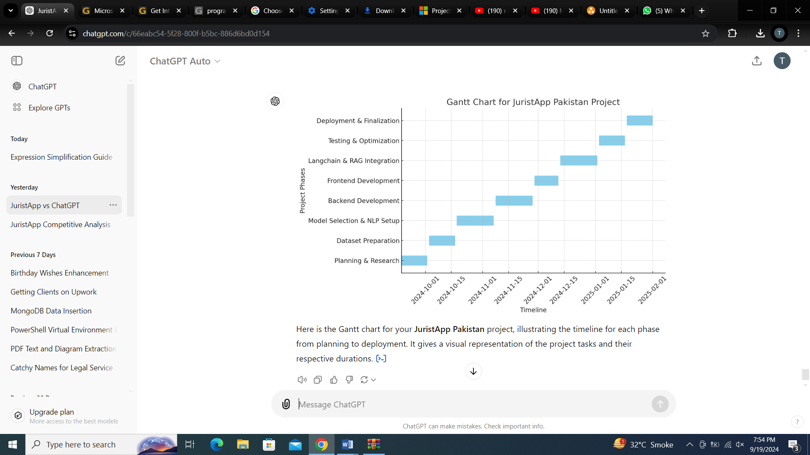

## Empathy Map

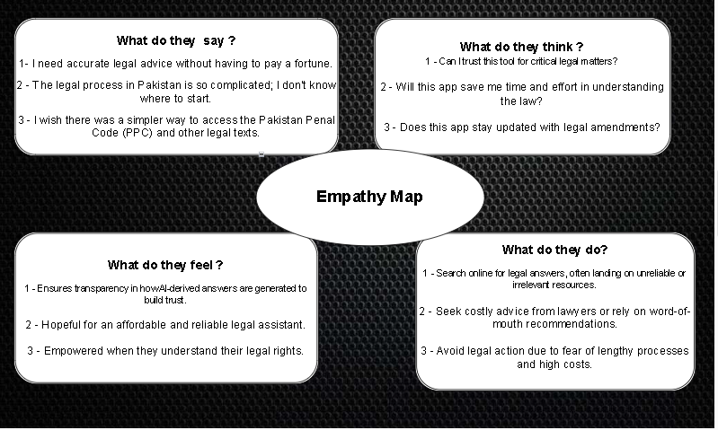

# 

# Chapter 2

# Data Collection

# : Data Collection



## Introduction

In fact, the success of JuristApp Pakistan greatly depends on the quality of the legal data that the application uses. As we know there are large number of lawa and reulations in Pakistan. Accessing, processing and storing this data gets complicated . The following sections describe the preprocessing and organization of data for acquisition, analysis and database of sources.

### Sources of Data

The primary source of legal data for JuristApp is the Pakistan Code [website](https://pakistancode.gov.pk/english/UY2FqaJw1-apaUY2Fqa-apaUY2Npa5lo-sg-jjjjjjjjjjjjj), accessible at the official government founded currently updated legal documents are available such as Pakistan Penal Code (PPC), Civil Procedure Code (CPC) and Criminal Procedure Code (CrPC). The data is available in the public domain therefore it is credible and accurate for use in the project.

### Access the Data

The data can be accessed by downloading the legal documents from the Pakistan Code website. Actions involved in this process involved moving from one site to another in search of the sector of the PPC, CPC, and CrPC. Originally, to enhance data credibility, every document collected will be checked for correctness and omissions. Any issues encountered during the access process were documented for future improvements.

## Data preparation

The raw data acquired from the Pakistan Code website was in various formats, including HTML and PDFs. Preparing the data for use involved parsing these formats into a structured and machine-readable form, such as JSON or CSV. This step included cleaning the data to remove duplicates, irrelevant sections, or formatting inconsistencies. Key legal terminologies were tagged for easier reference, ensuring that the dataset was optimized for NLP and machine learning processes.

## Data Storage

Once the data was prepared, it was initially stored in local storage systems to ensure quick and secure access during the development phase. However, as the application scales, transitioning to advanced cloud-based solutions such as Firebase Firestore or AWS RDS is recommended. These scalable databases provide robust storage capabilities, allowing for efficient data retrieval, real-time updates, and seamless integration with the platform’s backend. Regular backups and access control mechanisms are also crucial to maintain data security and integrity, ensuring the system remains adaptable to future expansions and updates.

## Data Validation

The data were processed in a rigorous validation process to ensure the accuracy and usability of the dataset. This step involved checking for errors, inconsistencies, missing values, and redundancies. Validation scripts were written to identify and flag anomalies in the dataset, ensuring that only clean, accurate and consistent data were used in subsequent steps This process was essential for minimizing errors during analysis and ensuring the reliability of the platform’s outputs.

## Data privacy and security

While privacy and security measures are still being developed, JuristApp guarantees that the Pakistan Penal Code (PPC) and other legal documents within the system cannot be altered. This approach preserves the integrity and authenticity of the data, allowing users to depend on the platform for reliable legal information. Future updates will introduce enhanced security protocols, such as encryption, user access controls, and adherence to local and international data protection regulations, to further protect the dataset and uphold user confidence

# 

# Chapter 3

# Data Exploration

# Data Exploration

This chapter examines the characteristics and structure of the dataset utilized in the development of JuristApp. It offers an in-depth analysis of the data, highlighting its features and how they align with the platform's objectives. By gaining insight into the composition and extent of the dataset, this chapter establishes a foundation for employing generative AI techniques to develop an intuitive and precise legal assistant. The analysis emphasizes the identification of trends, patterns, and anomalies to ensure the dataset’s efficacy in addressing complex legal inquiries.

## Description of Dataset

This chapter explains the characteristics and structure of the dataset utilized in the development of JuristApp. It offers an in-depth analysis of the data, highlighting its features and how they align with the platform's objectives. By gaining insight into the composition and extent of the dataset, this chapter establishes a foundation for employing generative AI techniques to develop an intuitive and precise legal assistant. The analysis emphasizes the identification of trends, patterns, and anomalies to ensure the dataset’s efficacy in addressing complex legal inquiries.

## Descriptive statistics

The text corpus is 179 distinct pages of text extracted from the PPC, which are publicly available on the website of the Pakistan Code. As of now, the model is being trained exclusively on the PPC to ensure a focused and accurate foundation for the platform. Nevertheless, the provisions have been made to add the CPC and CrPC into the dataset for larger data enlargement in the forthcoming versions. This structured dataset includes detailed legal provisions, clauses, and procedural guidelines. Key observations include the presence of hierarchical structures, such as sections and subsections, which are crucial for NLP-based parsing. By building on this comprehensive dataset, the platform ensures precise and context-aware legal assistance while maintaining scalability for further enhancements.

## Visualizations

All the Visualization is done through by using **PowerBi** Tool, Data Source **Pakistan Beauro [8]**

**Reported cases sorted by Year:**

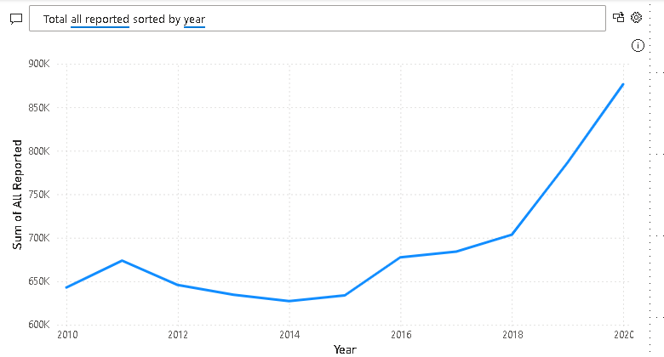

Figure3.1

**Total Crime By Year Represented in Bar chart:**

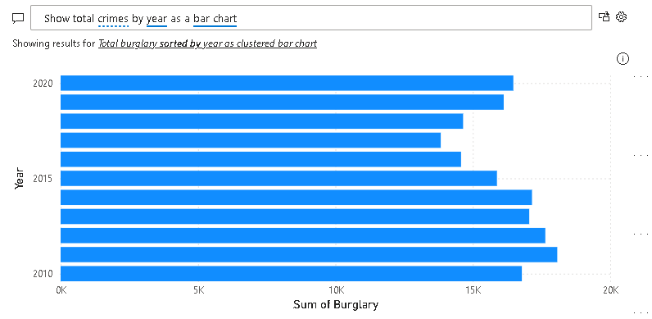

Figure 3.2

**Total Crimes Over the Years:**

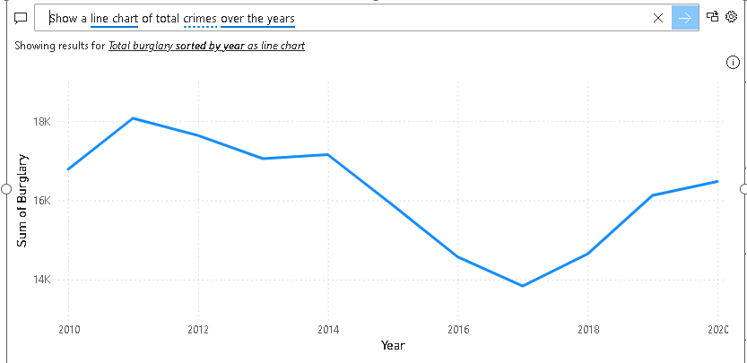

Figure 3.3

**Representation of Burglary, Robbery and Motor Vehicle Theft:**

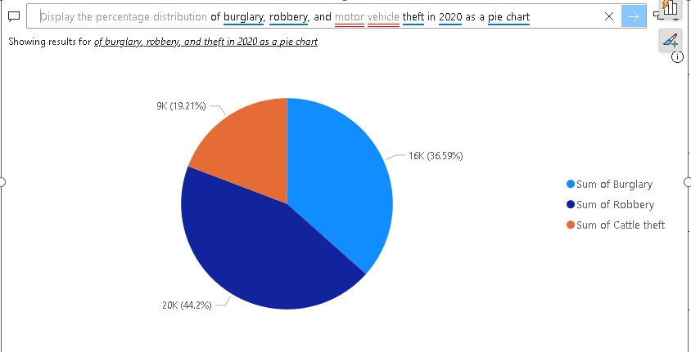

Figure 3.4

**Representation of Attempted Murder , Murder in 2020:**

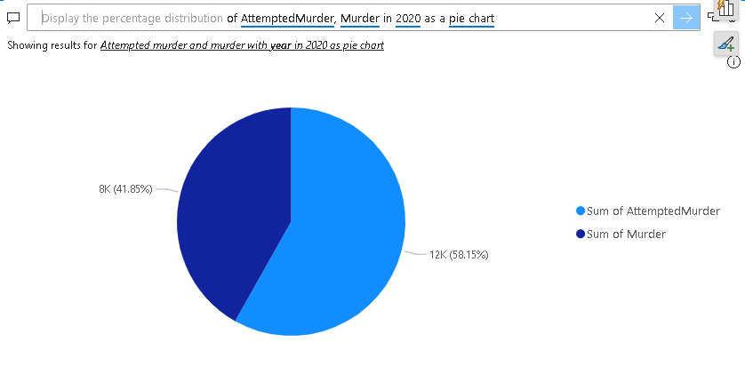

figure 3.5

## Data Correlation

In this section, we examine the relationships among various features of the dataset, such as legal provisions, texts, and entries. By analyzing the interactions between variables such as sanctions, procedural rules, and their jurisdictional applications, we examine models that can affect understandings of legal complexity. For example, statistical analyzes show that a systemic barrier is often associated with a particular crime, indicating that legal system iterative modeling These correlations help identify areas of overlap or inconsistency in legal systems, ensure to take a comprehensive approach to dataset processing Lays the foundation for customizing NLP models of the platform.

# Chapter 4

# Data Cleaning

# Data Cleaning

**Introduction:**

Data Cleaning is an important step in the development of JuristApp Pakistan to ensure that the legal answers are accurate, relevant and reliable.

It describes the programming approach to identifying, managing, and preparing a data structure for optimal performance in an application.

## Description of the data cleaning process

* The data cleaning process included several steps such as identifying anomalies, handling missing values, and ensuring data quality.
* Techniques such as keyword extraction, data validation, and standardization were used to maintain data integrity.

## Identification of data issues:

* Missing values in specific sections of PPC, CPC, and CrPC.
* Outliers due to formatting inconsistencies in legal provisions.
* Duplicate entries in the dataset leading to redundancy.
* Inconsistent terminologies and legal references.

## Handling of missing values:

* Imputation was used for missing values by referencing official legal documents.
* Interpolation methods applied for numerical data where applicable.

## Handling of inconsistencies:

* Corrected errors in legal text formatting and terminology.
* Removed duplicate observations to streamline the dataset.

## Data type conversion:

* Converted text-based sections into structured formats (e.g., JSON, CSV) for easier processing.
* Standardized date formats and numerical entries for consistency

## Data normalization:

* Applied scaling techniques to ensure uniformity across numerical data.
* Standardized legal text to match predefined templates for queries.

## Conclusion:

The data cleaning process addressed significant challenges, such as missing values, inconsistencies, and redundancies, ensuring a high-quality dataset. These efforts provide a robust foundation for accurate legal query resolution and pave the way for efficient application performance.

# Chapter 5

# Purposed Methodology

**Introduction:**

This chapter explains the strategies, models and techniques used in the development of JuristApp Pakistan. Incorporating state-of-the-art AI models, the application ensures a comprehensive, scalable and user-centered solution for legal queries.

**Methods**

**Natural Language Processing (NLP):**

* Process and analyze user queries for extracting relevant keywords and context.

**GPT-4 Turbo Integration:**

* Utilize OpenAI's GPT-4 Turbo model for generating accurate, context-aware responses.

**Vector Database (Pinecone):**

* Store and retrieve embeddings of legal data to ensure quick and efficient response generation.

**Streamlit Deployment:**

* Provide an interactive web interface for model deployment and user interaction.

**Continuous Learning through Feedback Loops:**

* Enhance the system’s accuracy by iteratively learning from user interactions and updating datasets.

**Model Selection**

* Chosen Model: GPT-4 Turbo

**Why GPT-4 Turbo?**

* Provides advanced conversational capabilities, ensuring coherent and contextually accurate responses.
* Handles complex legal queries with precision, reducing ambiguity.
* Combined with Pinecone for embedding management, GPT-4 Turbo enables efficient query processing and retrieval.

**Architecture Diagram:**

**System Components:**

**Frontend:**

* Built using Streamlit for an intuitive and responsive user interface.
* Facilitates user queries and displays results seamlessly.

**Backend:**

* Developed with Python/Django to handle API requests and manage query flow.

**Machine Learning Engine:**

* Powered by GPT-4 Turbo, integrated with:
* Vector Database (Pinecone) for embedding storage and retrieval.
* Fine-tuned datasets from PPC, CPC, and CrPC.

**Database:**

* Cloud-based storage for managing structured legal texts and user interaction data.

**Workflow:**

* User submits a query via the Streamlit interface.
* Query is processed by the backend and embeddings are retrieved from Pinecone.
* GPT-4 Turbo generates a response based on the embeddings and query context.
* Response is displayed to the user on the Streamlit interface.

**Conclusion:**

By leveraging GPT-4 Turbo and Pinecone, along with a robust deployment strategy via Streamlit, JuristApp Pakistan ensures accurate and efficient legal query handling. The scalable and modular architecture supports future enhancements, ensuring the app remains a cutting-edge tool for localized legal assistance.

**Architecture Diagram:**

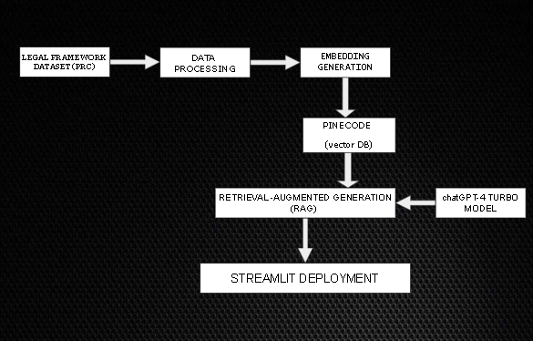

**Figure 5.1**

# 

**Reference and Bibliography**

[1] M. Sher, M. Rehman, “*Title of the Paper*” Conference name/Journal Name, Edition, Volume, Issue, ISBN/ISSN, PP, Publ

[2] AllahRakha, N. Modernizing Punishment: Comparative Analysis on Pakistan's Penal Code. *Available at SSRN 5036330*.

[3] Papracha, S., Sultan, D. K., & Jan, M. (2012). Historical & Professionals' Paradigm of Pakistan Penal Code Pertaining to the Press. *International Journal of Management Sciences and Business Research*, *1*(5).

[4] Khan, N., Ahmed, J., Nawaz, M., & Zaman, K. (2015). The socio-economic determinants of crime in Pakistan: New evidence on an old debate. *Arab Economic and Business Journal*, *10*(2), 73-81.

[5] Jalil, H. H., & Iqbal, M. M. (2010). Urbanisation and crime: A case study of Pakistan. *The Pakistan Development Review*, 741-755.

[6] Safdar, G., Shabir, G., & Javed, M. N. (2016). Culture of Violence: A Case Study of Pakistan. *Culture*, *20*.

[7] Shahid, M., Ahmad, K., Inayat, M. A., & Bhatti, M. K. (2024). Socio-Economic Determinants of Property Crime Across the Districts of Punjab: Highlighting the Role of Law Enforcement Agencies of Pakistan. *Bulletin of Business and Economics (BBE)*, *13*(2), 22-36.

[8] https://www.pbs.gov.pk/sites/default/files/tables/social_statistics/crime_report.pdf

1.